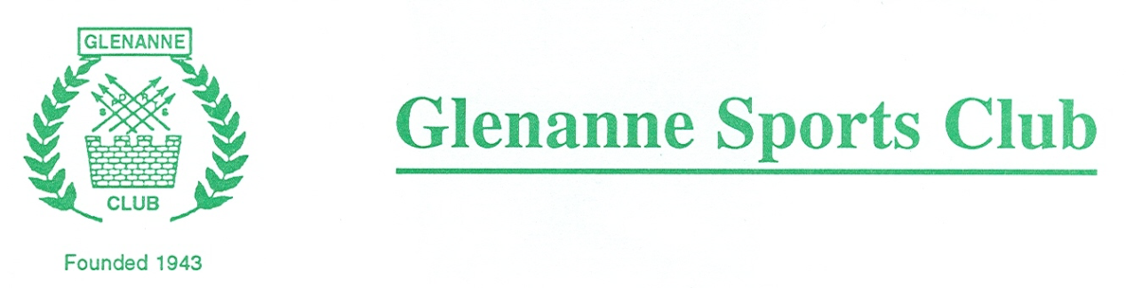

GLENANNE SPORTS CLUB DATA PRIVACY POLICY
1. About this Policy
  - This policy explains when and why we collect personal information about our members and instructors, how we use it and how we keep it secure and your rights in relation to it.
  - We may collect, use and store your personal data, as described in this Data Privacy Policy and as described when we collect data from you.
  - We reserve the right to amend this Data Privacy Policy from time to time without prior notice. You are advised to check our website https://www.glenannehockeyclub.com regularly for any amendments (but amendments will not be made retrospectively).
  - We will always comply with the General Data Protection Regulation (GDPR) when dealing with your personal data. For the purposes of the GDPR we will be the “controller” of all personal data we hold about you.

- Who are we?
  - We are Glenanne Sports Club. We can be contacted by post at Glenanne Park, St Marks Community School, Tallaght, Dublin 24 or by email at secglenannehockeyclub@gmail.com
- What information we collect and why.
Type of Information | Purposes | Legal bases of processing
Member’s name, address, telephone number, e-mail addresses | Managing the Member’s membership of the Club. Managing the duty roster | Performing the Club’s contract with the Member.  For the purposes of our legitimate interests in operating the club
The names and ages of the Member’s dependents | Managing the Member’s and their dependants’ membership of the Club | Performing the Club’s contract with the Member.
Date of birth / age related information | Managing membership categories which are age related | Performing the Club’s contract with the Member.
Gender | Provision of adequate facilities for members  Reporting information to Branch and Hockey Ireland | For the purposes of our legitimate interests in making sure that we can provide sufficient and suitable facilities (including changing rooms and toilets) for each gender.  For the legitimate interests of the Branch and Hockey Ireland to maintain diversity of data required by Sport Ireland and Sport NI.
Photos and videos of Members | Putting on the Club’s website and social media pages and using in press releases | Consent. We will seek the Member’s consent on their membership application form and each membership renewal form and the Member may withdraw their consent at any time by contacting us by e-mail or letter.
The Member’s name and e-mail address | Creating and managing the Club’s online Membership Directory | Consent. We will seek the Member’s consent on their membership application form and each membership renewal form and the Member may withdraw their consent at any time by contacting us by e-mail or letter.
Bank account details of the Member or other person making payment to the Club | Managing the Member’s and their dependants’ membership of the Club, the provision of services and event. | Performing the Club’s contract with the Member.
Coach’s name, address, email addresses, phone numbers and relevant qualification and/or experience | Managing coaching at the Club. | For the purposes of our legitimate interests in ensuring that we can contact those offering coaching and provide details of coaches to members.
Coach’s / Volunteers name, address, email addresses, phone numbers and ID | Processing Garda Vetting for coaches / volunteers working with children or vulnerable adults | Child protection within the Club.

- How we protect your personal data.

  - We will not transfer your personal data outside the EU without your consent.
  - We have implemented generally accepted standards of technology and operational security to protect personal data from loss, misuse, or unauthorised alternation or destruction.
  - Please note however that where you are transmitting information to us over the internet this can never be guaranteed to be 100% secure.
  - For any payments which we take from you online we will use a recognised online secure payment system.
  - We will notify you promptly in the event of any breach of your personal data which might expose you to serious risk.

- Who else has access to the information you provide us?
  - We will never sell your personal data. We will not share your personal data with any third parties without your prior consent (which you are free to withhold) except where required to do so by law or as set out in the table above or paragraph 5.2 below.
  - We may pass your personal data to third parties who are service providers, agents and subcontractors to us for the purposes of completing tasks and providing services to you on our behalf (e.g. to print newsletters and send you mailings). However, we disclose only the personal data that is necessary for the third party to deliver the service and we have a contract in place that requires them to keep your information secure and not to use it for their own purposes.
  - We will pass your data to Leinster Hockey Association and to Hockey Ireland for the purposes of maintaining a membership database.

- How long do we keep your information?
  - We will hold your personal data on our systems for as long as you are a member of the Club and for as long afterwards as it is in the Clubs’ legitimate interest to do so or for as long as is necessary to comply with our legal obligations. We will review your personal data every year to establish whether we are still entitled to process it. If we decide that we are not entitled to do so, we will stop processing your personal data except that we will retain your personal data in an archived form to able to comply with future legal obligations, e.g. compliance with tax requirements and exemptions, and the establishment exercise or defence of legal claims.
  - We securely destroy all financial information once we have use4d it and no longer need it.

- Your rights
  - You have rights under the GDPR:

      - To access your personal data
      - To be provided with information about how your personal data is processed
      - To have your personal data corrected
      - To have your personal data erased in certain circumstances
      - To object to or restrict how your personal data is processed
      - To have your personal data transferred to yourself or to another business in certain circumstances.
  - You have the right to take any complaints about how we process your personal data to the Data Protection Commissioner.
info@dataprotection.ie
Data Protection Commissioner
Canal House
Station Road
Portarlington
Telephone | +353 57 8684800  +353 (0)761 104 800
Lo Call Number | 1890 252 231
Fax | +353 57 868 4757

For more details, please address any questions, comments and request regarding our data processing practices to secglenannehockeyclub@gmail.com

